EMCH 354, Spring 2024, Mid-term Test 02/22/2024 University of South Carolina
Name: Jacob C. Vaught Score: _____
- Which type of the major heat transfer mode is taking place (15’)
- Heat spreading on pure copper plates: Conduction. Heat is transferred through the material itself, without any movement of the material.
- Water cooling: Convection. The movement of water facilitates the transfer of heat from the hot object to the cooler water.
- Ironing a shirt: Conduction (for the heat transfer from the iron to the shirt) and radiation (from the iron to the air).
- Boiling water: Convection within the water as it heats up and natural convection as the hot water rises and the cooler water descends.
- Grilling a steak: Radiation (from the heat source to the steak) and conduction (heat transferring into the interior of the steak).
- Microwave oven: Radiation (microwaves penetrate the food, causing water molecules within to vibrate and heat up).
- A metal spoon becomes hot from a hot coffee in a cup: Conduction (heat transfers from the hot coffee through the spoon).
- Stir frying vegetables: Conduction (from the pan to the vegetables) and MAYBE convection (as the vegetables move around the pan).
- Hot air balloon rises: Convection (hot air rising within the balloon creates lift).
- Radiator warms your hands: Radiation (heat emitted from the radiator) and MAYBE convection (warm air circulating around the room).

- In a 1D domain, -1m ≤ x ≤ 1m, the temperature profile is given T(x) = -100 x² + 10 x + 5 ºC. Estimate the heat flux at a location, x = 0 m, if the thermal conductivity of the material is 10 W/(m·K). (5’)

T(x) = -100 x² + 10 x + 5 ºC
Derivative: -200x+10, and at x=0, =10$°$ C/m
$$q=-k*\frac{dT}{dx}=-10*10=-100 W/m^{2}$$

- The conduction heat transfer rate, q, through a spherical shell is equal to $\frac{ΔT⋅4πk}{\frac{1}{r_{1}}-\frac{1}{r_{2}}}$, where ∆T, r1, and r2 are thermal conductivity, temperature difference across the shell, inner and outer radius of the shell and assumed to be given. Derive the thermal resistance for this heat transfer process. (10’)
$$R_{th}=\frac{ΔT}{q}$$
$$q=\frac{ΔT⋅4πk}{\frac{1}{r_{1}}-\frac{1}{r_{2}}}$$
$$ΔT=q⋅\left(\frac{1}{4πk}\left(\frac{1}{r_{1}}-\frac{1}{r_{2}}\right)\right)$$
$$R_{th}=\frac{1}{4πk}\left(\frac{1}{r_{1}}-\frac{1}{r_{2}}\right)$$
Not sure if correct. TODO: Review if time.

- A hollow cylinder, of inner and outer diameters 3 and 5 cm, respectively, has an inner surface temperature of 400 K in steady state. The outer surface temperature is 326 K when exposed to fluid at 300 K with an outside heat transfer coefficient of 27 W/(m²K). What is the thermal conductivity of the cylinder? (10’)
$$q=\frac{2πkL\left(T_{i}-T_{o}\right)}{\ln\left(\frac{r_{o}}{r_{i}}\right)}, and q=hA_{o}\left(T_{surf}-T_{fluid}\right)$$
Thus,
$$\frac{2πkL\left(T_{i}-T_{o}\right)}{\ln\left(\frac{r_{o}}{r_{i}}\right)}=hA_{o}\left(T_{surf}-T_{fluid}\right)$$
$$2πkL\left(T_{i}-T_{o}\right)=hA_{o}\left(T_{surf}-T_{fluid}\right)*\ln\left(\frac{r_{o}}{r_{i}}\right)$$
$$k=\frac{h2πr_{o}\left(T_{surf}-T_{fluid}\right)*\ln\left(\frac{r_{o}}{r_{i}}\right)}{2πL\left(T_{i}-T_{o}\right)}$$
$$k=\frac{27*2π*0.025*\left(26°K\right)*\ln\left(\frac{0.025}{0.015}\right)}{2π*\left(400-326\right)}≈0.121\frac{W}{m⋅K}$$

- A special-purpose oil flows at 45.25 kg/(m²ˑs) inside a 10 cm-long duct with a crosssection (1 cm × 3 cm) that is heated electrically at a rate of 300 W/m² along the length direction. For thermal properties, take k = 0.139 W/m-K, ρ = 854 kg/m³, c_{p} = 2120 J/kg∙K, and kinematic viscosity, ν = 4.1 x 10⁻⁵ m²/s. (32’) Determine

a) Mass flow rate, $\dot{m}=flux*A=0.013575 kg/s$
  - Volumetric flow rate, $\dot{V}={\dot{m}}/ρ=1.5896*{10}^{-5} m^{3}/s$
  - The bulk fluid velocity, $v=\frac{\dot{V}}{A}=0.052986 m/s$
  - Reynolds number, $Re=ρ*v*\frac{D_{h}}{μ}=19.385$ INDICATING Laminar Flow
  - Convective heat transfer coefficient can be determined by $h_{c}=4.8\frac{k}{D_{h}}$ if flow is fully developed: $h_{c}=4.8*k/D_{h}=44.48\frac{W}{m^{2}⋅K}$
  - Temperature difference between wall and bulk fluid, $T_{wb}=\frac{q^{'}}{h_{c}}=6.745 K$
  - Temperature difference between inlet and outlet, and $ΔT_{io}=\frac{q^{'}*L}{\dot{m}*c_{p}}=1.0424 °K$
  - Pressure drop gradient with 𝑓 ∙ 𝑅𝑒_{𝐷ℎ} = 69. $\frac{ΔP}{L}=\frac{f*0.5ρv^{2}}{D_{h}}=284.47 Pa/m$

Probably made some mistakes here. TODO: Review if time

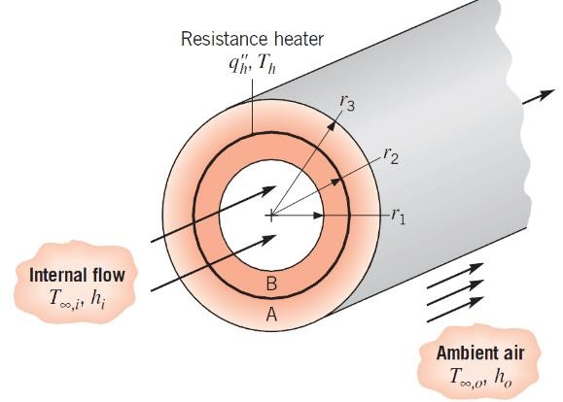
- A composite cylindrical wall is composed of two materials of thermal conductivity k_{A} and k_{B}, which are separated by a very thin, electric resistance heater for which interfacial contact resistances are negligible. Liquid pumped through the tube is at a temperature 𝑇_{∞,𝑖} and provides a convection coefficient ℎ_{𝑖} at the inner surface of the composite. The outer surface is exposed to ambient air, which is at 𝑇_{∞,𝑜} and provides a convection coefficient of ℎ_{𝑜}. Under steady-state conditions, a uniform heat flux of 𝑞_{ℎ}′′ is dissipated by the heater.
  - Sketch the equivalent thermal circuit of the system and express all resistances in terms of relevant variables. (10’)
$$R_{conv,i}=\frac{1}{h_{i}*2πr_{1}L}$$
$$R_{cond,b}=\frac{\ln\left(\frac{r_{2}}{r_{1}}\right)}{2πk_{B}L}$$
$$R_{cond,A}=\frac{\ln\left(\frac{r_{3}}{r_{2}}\right)}{2πk_{A}L}$$
$$R_{conv,o}=\frac{1}{h_{o}*2πr_{3}L}$$
$$R_{total}=R_{conv,i}+R_{cond,b}+R_{cond,A}+R_{conv,o}$$

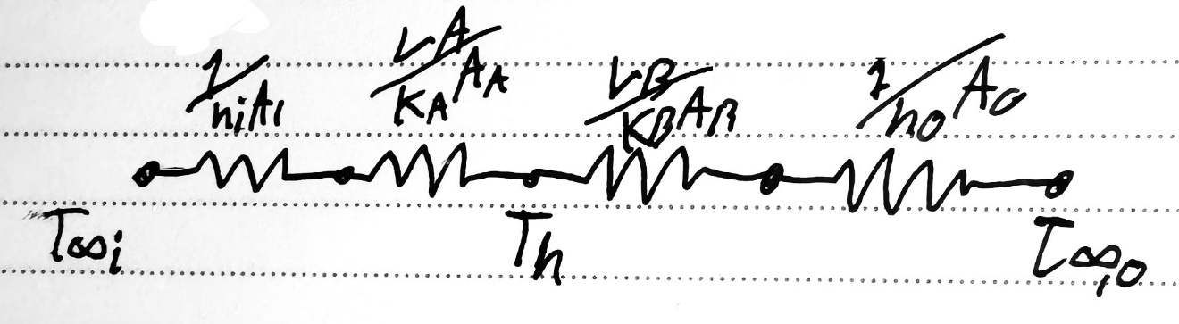

  - Obtain an expression that may be used to determine the heater temperature, 𝑇_{ℎ}. (10’)
From: $q^{''}=\frac{ΔT}{R_{total}},$ we get $T_{h}=q^{''}*R_{total}+T_{∞,o}$

  - Obtain an expression for the ratio of heat flows to the outer and inner fluids, (7’)
$$q_{o}^{''}=\frac{T_{h}-T_{∞,o}}{R_{conv,o}+R_{cond,A}}, \& q_{o}^{''}=\frac{T_{h}-T_{∞,i}}{R_{conv,i}+R_{cond,B}}$$

$$\frac{q_{o}^{''}}{q_{i}^{''}}=\frac{T_{h}-T_{∞,o}}{T_{h}-T_{∞,i}}×\frac{R_{conv,i}+R_{cond,B}}{R_{conv,o}+R_{cond,A}}$$

